Databases for Data Analytics
Task 4 - Aggregations and Grouping | Yaron Besser
Question 1 - Film noir / crime classical period
Task: The classical period of film noir / crime movies was the 1940s and 1950s. (a) Create a table of classical-period movies. (b) Find all pairs of these movies that share at least 3 actors.
(a) Building classical_movies
Row count: 1,898 rows
SQL Query:
DROP TABLE IF EXISTS classical_movies;
CREATE TABLE classical_movies AS
SELECT DISTINCT m.*
FROM movies AS m
JOIN movies_genres AS mg ON m.id = mg.movie_id
-- Note: 'Film-Noir' is treated as a genre in the IMDB database
WHERE mg.genre IN ('crime', 'Film-Noir')
AND m.`year` BETWEEN 1940 AND 1959;
(b) Pairs with at least 3 shared actors
Row count: 6,913 pairs (intermediate film_noir_actor_movie: 42,555 rows)
SQL Query:
-- Build a film-noir actor-movie table for the self-join
DROP TABLE IF EXISTS film_noir_actor_movie;
CREATE TABLE film_noir_actor_movie AS
SELECT actor_id, movie_id
FROM roles AS r
JOIN classical_movies AS cm ON r.movie_id = cm.id;

SELECT fnam1.movie_id, fnam2.movie_id, COUNT(*) AS count_commen_actors
FROM film_noir_actor_movie AS fnam1
JOIN film_noir_actor_movie AS fnam2 ON fnam1.actor_id = fnam2.actor_id
WHERE fnam1.movie_id > fnam2.movie_id
GROUP BY fnam1.movie_id, fnam2.movie_id
HAVING count_commen_actors >= 3;
Result and status:
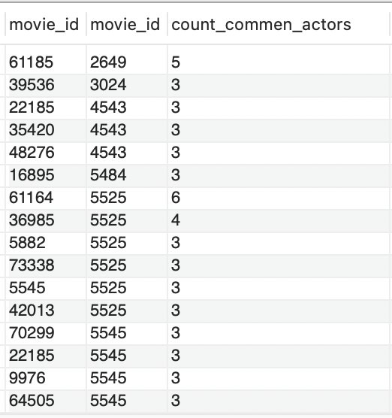
Explanation:
(a) Joined movies with movies_genres, filtered to genre 'crime' or 'Film-Noir' and years 1940-1959. DISTINCT m.* prevents duplicates from movies tagged with both genres. (b) Built film_noir_actor_movie as the actor-movie pairs from classical_movies, then joined it to itself on actor_id. HAVING count_commen_actors >= 3 keeps only pairs sharing 3+ actors.
Why fnam1.movie_id > fnam2.movie_id:
Without this condition the self-join produces two unwanted kinds of rows: reflexive matches (same movie paired with itself) and symmetric duplicates (every real pair (A, B) also appearing as (B, A)). Strict inequality > - rather than != - solves both at once: it forbids the self-pair and picks one ordering of each real pair, so each pair is counted exactly once.
Question 2 - Actors per role distribution
Task: (a) Build a table of number of actors per role. (b) Compute the distribution. (c) Can there be roles with zero actors?
(a) Building role_actor_count
Row count: 1,153,615 rows (one per distinct role)
SQL Query:
DROP TABLE IF EXISTS role_actor_count;
CREATE TABLE role_actor_count AS
SELECT `role`, COUNT(*) AS num_of_actors
FROM roles AS r
GROUP BY r.role;
(b) Distribution of actors per role
Row count: 646 buckets
SQL Query:
SELECT num_of_actors, COUNT(*) AS count_role
FROM role_actor_count
GROUP BY num_of_actors
ORDER BY num_of_actors;
Result and status:
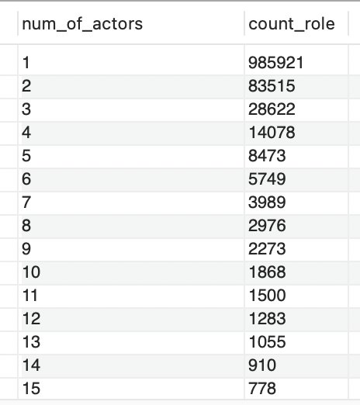
(c) Can there be roles with zero actors?
No. The roles table requires both a role string and an actor_id per row, so a role only exists in the data if at least one actor played it. Roles with zero actors cannot appear in this schema.
Explanation:
(a) One row per distinct role with the count of actor-entries playing it - 1,153,615 different role names. (b) Buckets the roles by their actor count: 985,921 roles have exactly 1 actor, then a long tail of higher counts (83,515 with 2 actors, 28,622 with 3, etc.). The result is sorted ascending by num_of_actors.

Question 3 - Typical role sets
Task: For each movie, build a string with all its role names. Use only roles played by at least 10 actors; deduplicate; order doesn't matter (use sorted form).
Row count: 178,254 movies
SQL Query:
SELECT m.id, m.name,
GROUP_CONCAT(DISTINCT r2.role ORDER BY r2.role) AS role_str
FROM (
SELECT role
FROM roles
WHERE role != ''
GROUP BY role
HAVING COUNT(*) >= 10
) AS r
JOIN roles AS r2 ON r.role = r2.role
JOIN movies AS m ON r2.movie_id = m.id
GROUP BY m.id, m.name;
Result and status:
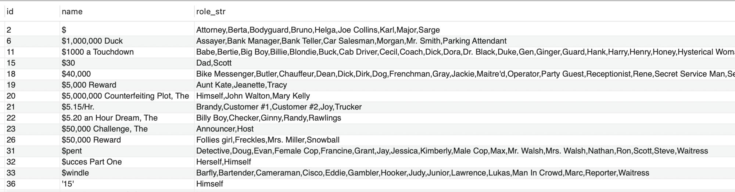
Explanation:
The inner subquery picks roles that appear at least 10 times in the roles table, excluding empty role names. Joining this back to roles and movies filters each movie's cast down to those frequent roles only. GROUP_CONCAT(DISTINCT r2.role ORDER BY r2.role) builds one string per movie containing all its frequent role names, deduplicated and sorted alphabetically. Two movies with the same cast structure produce the same string, which makes them easy to compare.

Question 4 - Role probability per movie and per genre
Task: Compute the probability of each role to appear in a movie and in a genre (e.g., the share of comedies that contain a 'clown' role).
Row count: 1,742,524 rows (role × genre combinations); genere_count: 21 rows
SQL Query:
-- Build a per-genre count table
DROP TABLE IF EXISTS genere_count;
CREATE TABLE genere_count AS
SELECT genre, COUNT(*) AS count_genre
FROM movies_genres
GROUP BY genre;

SELECT
r.role,
COUNT(*) / (SELECT COUNT(*) FROM movies) AS prop_of_movies,
mg.genre,
COUNT(*) / gc.count_genre AS prop_of_genre
FROM roles AS r
JOIN movies_genres AS mg ON r.movie_id = mg.movie_id
JOIN genere_count AS gc ON mg.genre = gc.genre
WHERE r.role != ''
GROUP BY r.role, mg.genre, gc.count_genre;
Result and status:
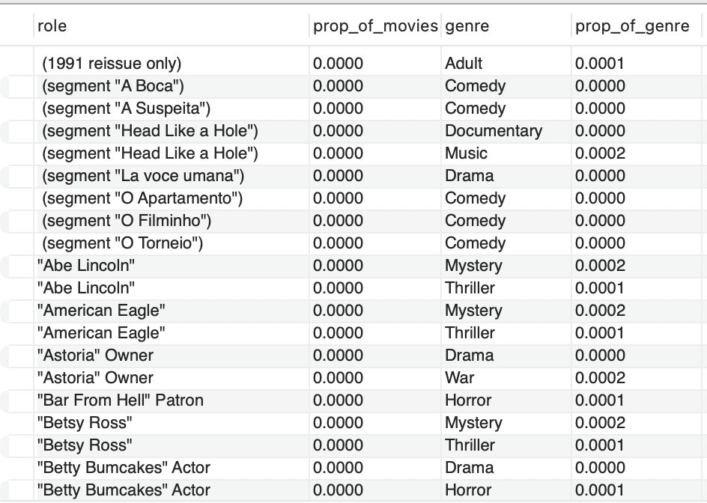
Explanation:
First built genere_count with the total number of movies in each genre - 21 rows, one per genre. Then joined roles with movies_genres and genere_count, grouped by (role, genre), and computed two ratios. prop_of_movies = COUNT(*) / total movies gives the share of all movies that contain this role-genre pairing. prop_of_genre = COUNT(*) / count_genre gives the share of movies within that genre that contain this role. Filtered out empty role names.

Question 5 - Interesting question: actor-genre concentration
Question: For each actor, what fraction of their movies falls in each genre? This shows where each actor is concentrated in their career.
Row count: 1,893,605 rows (full result, 59.173 sec)
SQL Query:
SELECT
ac.id AS actor_id,
ac.first_name, ac.last_name,
mg.genre,
COUNT(DISTINCT r2.movie_id) / a_movies_count AS prop_genre
FROM (
SELECT a.id, a.first_name, a.last_name,
COUNT(DISTINCT r.movie_id) AS a_movies_count
FROM actors AS a
JOIN roles AS r ON a.id = r.actor_id
GROUP BY a.id
) AS ac
JOIN roles AS r2 ON ac.id = r2.actor_id
JOIN movies_genres AS mg ON r2.movie_id = mg.movie_id
GROUP BY ac.id, ac.first_name, ac.last_name, mg.genre
ORDER BY actor_id, prop_genre DESC;
Result and status:
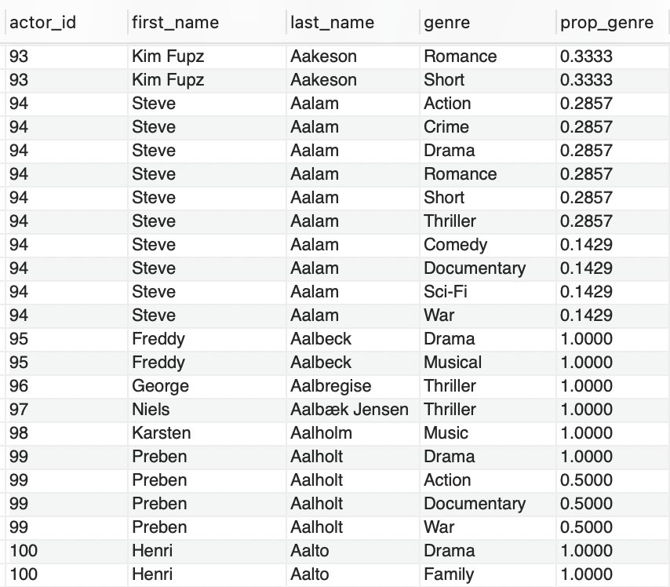
Explanation:
Inner subquery ac computes each actor's total distinct movies (a_movies_count). Joining this back to roles and movies_genres, then grouping by (actor, genre), gives the share of each actor's movies that fall in each genre: prop_genre = COUNT(DISTINCT r2.movie_id) / a_movies_count.
Why COUNT(DISTINCT movie_id):
An actor can have multiple roles entries for the same movie, and a movie can have multiple genre tags. Without DISTINCT, a movie tagged with two genres would be double-counted for each role entry the actor has in it. DISTINCT movie_id guarantees we count movies, not row pairings - both in the inner subquery (total movies) and in the outer count (movies per genre).
Why probabilities can sum to over 1 for one actor:
Movies in the IMDB schema can carry multiple genre tags. A film tagged both Comedy and Romance contributes to both genre proportions for its actor. Example from the result: Steve Aalam (id 94) has 7 distinct movies, and his prop_genre values sum to ~2.29 across his genres - meaning his films average about 2.3 genre tags each. prop_genre measures presence in each genre, not exclusive concentration.

